http://go.hrw.com/jupiter/images/spacer.gifhttp://go.hrw.com/jupiter/images/spacer.gif

**der Kophörer**

**die Fernbedienung**

**das Farbfernsehgerät**

**die Zimmerantenne**

**der Fernsehwagen**

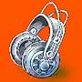http://go.hrw.com/jupiter/images/spacer.gif

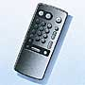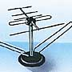

http://go.hrw.com/jupiter/images/spacer.gif

http://go.hrw.com/jupiter/images/spacer.gif

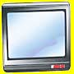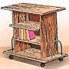

http://go.hrw.com/jupiter/images/spacer.gifhttp://go.hrw.com/jupiter/images/spacer.gifhttp://go.hrw.com/jupiter/images/spacer.gifhttp://go.hrw.com/jupiter/images/spacer.gif

**Scheibenwischer**

**eine Klimaanlage**

**eine Fussbremse**

**Scheinwerfer**

http://go.hrw.com/jupiter/images/spacer.gif

**Reifen/Breitreifen**

**ein Schiebedach**

**eine Handbremse**

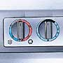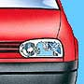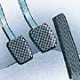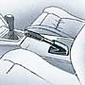http://go.hrw.com/jupiter/images/spacer.gif

http://go.hrw.com/jupiter/images/spacer.gif

http://go.hrw.com/jupiter/images/spacer.gif

http://go.hrw.com/jupiter/images/spacer.gif

